SPRING PET-CLINIC DOCIMENTATION:

STEP -1

* START AN INSTANCE ON AWS MACHINE
* CONNECT TO THE LINUX MACHINE

STEP – 2

OPEN TERMINAL

* RUN THE COMMAND “ sudo apt update ”
* RUN THE COMMAND “ sudo  apt install openjdk-11-jdk”
* 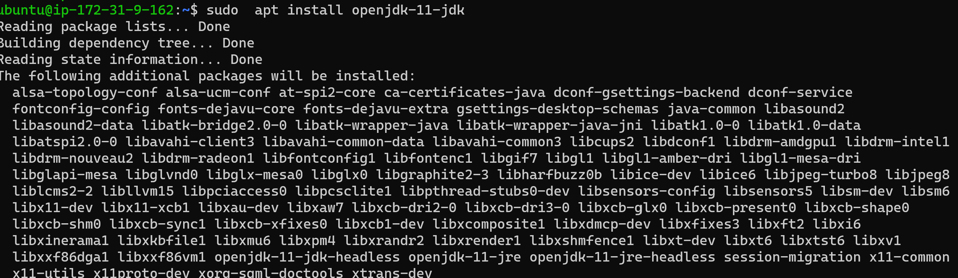
* THIS INSTALLS THE JAVA 11 ON OUR LINUX SYSTEM
* (REASON: CAUSE THE SPRING PET_CLINC USES THE JAVA CODE)

STEP -3

- INSTALL THE SPRING PET-CLINC WEB SERVER ON THE LINUX MACHINE

USING THE COMMAND “wget <https://referenceapplicationskhaja.s3.us-west-2.amazonaws.com/spring-petclinic-2.4.2.jar>”

- 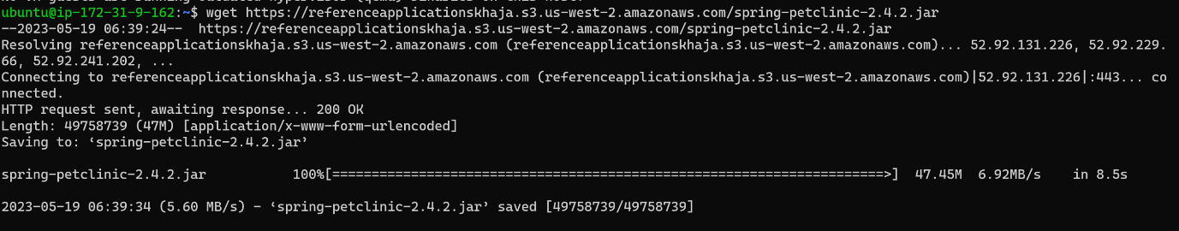

STEP-4

TO START THE APPLICTION ON THE SERVER

USE THE COMMAND TO CONFIGURE

 “java -jar /spring-petclinic-2.4.2.jar”

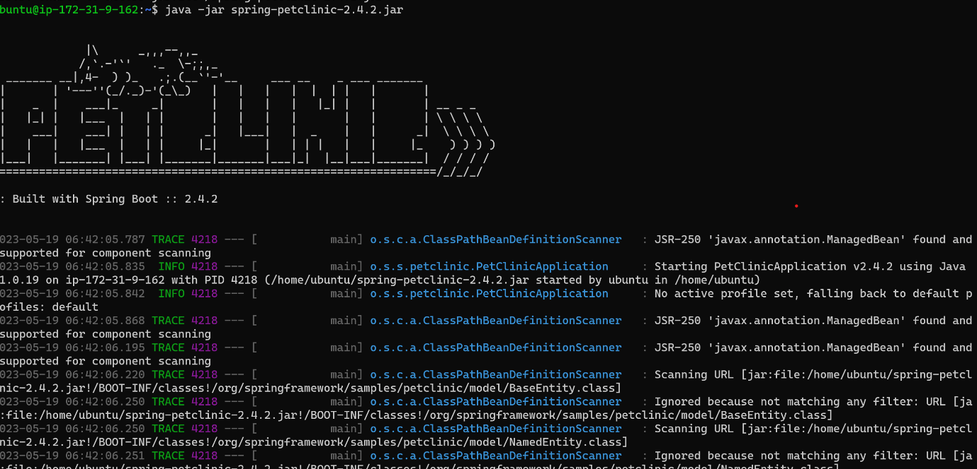

STEP-5

NOW RUN THE WED SERVER USING THE PORT NUMBER

8080 {example :([http://ip:8080](http://ip:8080/))}

YOUR BROWSER SHOULD LOOK SOMETHING LIKE THIS

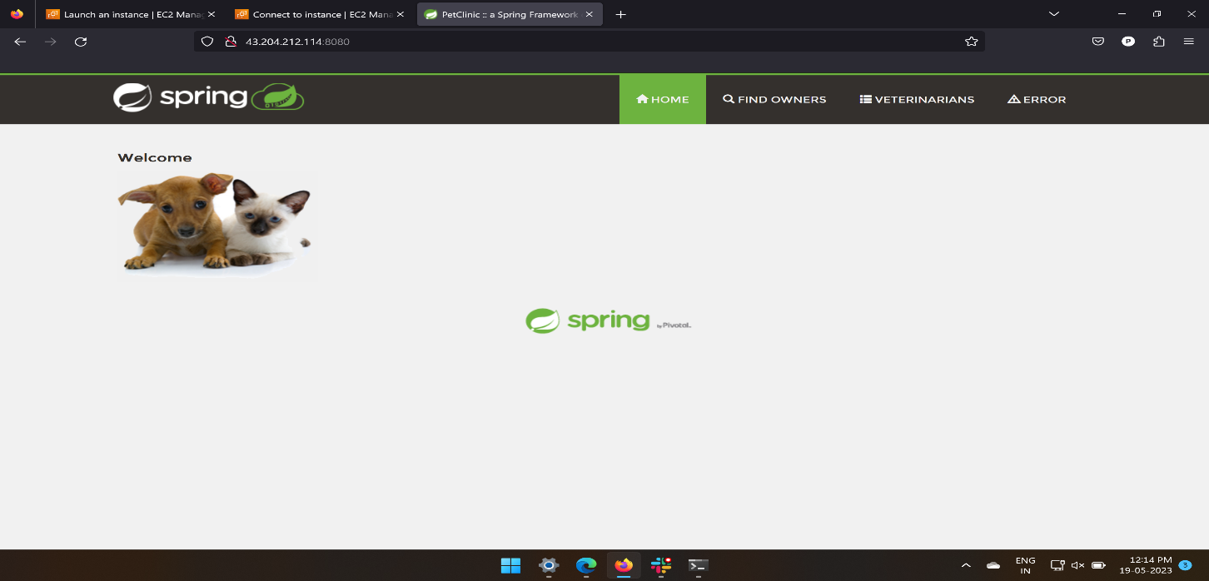

STEP-5

* NOW THE WEB SERVER WILL BE UP UNTILL YOU ARE IN THE SERVER
* BUT WE WANT IT TO RUN EVEN AFTER LOGGING OUT OF IT SO,
* WE NOW WRITE A SERVICE FILE WHICH RUN IN THE BACKGROUND AND WEB SERVER WILL BE UP UNTILL THE SYSTEM RUNS

GO TO

/lib/systemd/system/ we will find the service files in it

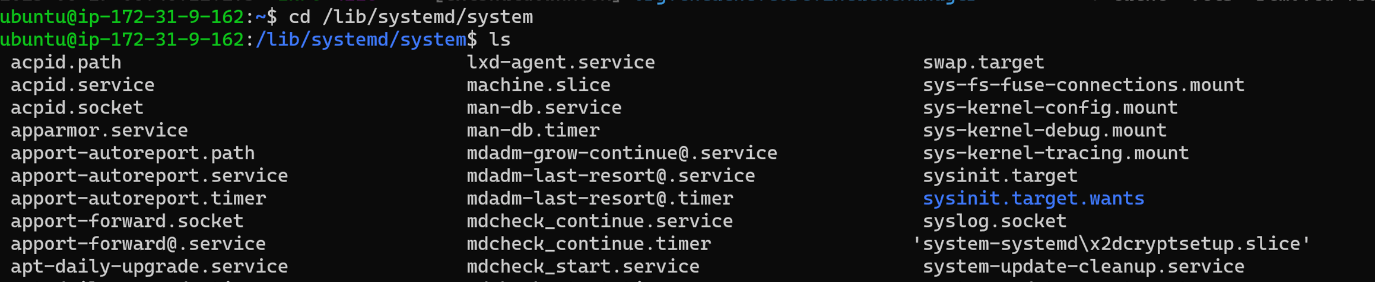

AND CREATE A SERVICE FILE USING THE COMMAND

sudo vi <any name>.service

and copy the command in it

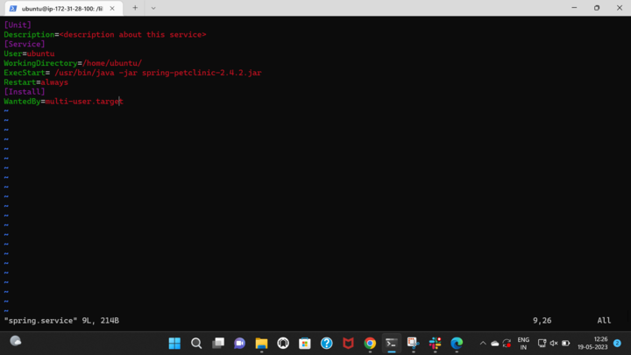

NOW ENABLE AND START THE SERVICE

USING THE COMMANDS

_- sudo systemctl enable <name>.service

* Sudo systemctl start<name>.service
* And now look at the status
* Sudo systemctl status<name>.service

